Master Thesis

|  |
| --- |
| Intraday pairs trading opportunities in an American Depositary Receipt with a consistent price premium: The Ryanair Case |

Fernando Lasso

1st of June 2020

MSc in Business Analytics

Introduction 5

Context 5

ADR and the Law of One Price 6

Research question and relevance 7

Thesis structure and outlook 7

Theoretical Framework 9

ADR premium and discount mechanisms 9

The Ryanair case 10

Pair selection 11

Hedge ratio estimation 13

Kalman filtering 14

Data and resources 16

Data sources and format 16

Resources 17

Descriptive statistics 17

Methodology 20

Back testing engine structure 20

Slippage model and assumptions 21

Trade signals in the Benchmark and Kalman classes 24

Parameter inputs 26

Parameter optimization 28

Results 31

Results introduction 31

Cointegration 31

Best parameters 33

Hedge ratio calculations 35

Algorithm performance metrics 37

Benchmark class performance 38

Kalman class performance 40

Conclusion 44

Limitations 44

Final words 44

Bibliography 45

Appendix 48

Kalman filter equations 48

Data and Methodology tables 50

All Results 53

# Abstract

Under the Law of One Price, two intrinsically equal products should trade at the same value. However, this intuitive logic does not hold for the pair of Ryanair American Depositary Receipt trading on the NASDAQ versus its LSE traded ordinary share counterpart. This research attempts to exploit the opportunity arising from the consistent price premium due to European ownership limits in the Irish airline. Although a benchmark using a simple ordinary least squares based cointegrated pair trading technique does not identify any opportunities, we find that iteratively forecasting the appropriate hedge ratio by the Kalman filter algorithm produces consistent returns with Sharpe ratios above two.

# Introduction

## Context

In today’s globalized economy, stock markets play the essential role of connecting investors to equity. The popular view of trading often brings up the stereotype of open outcry pit trading or Wolf of Wallstreet style cold calling. However, the past thirty years have seen radical transformations of stock market structures and their internal workings. Trades are directly registered in the matching engines of electronic exchanges and a vast majority of them run through specialized algorithmic trading departments of big banks or liquidity providing market makers. Most trading decision are made through algorithms that run on computers executing on behalf of traders (Wigglesworth & Rennison, 2018). Companies pour millions in their trading systems to benefit of the plumbing of the trading environment.

Some strategies purely rely on speed and taking advantage of arbitrage opportunities that occur every fraction of a second by processing pricing signals between different exchanges faster than the competition. However, other mechanisms have been developed and optimized to realize low-risk returns based on the intrinsic properties of assets. One method of such statistical arbitrage involves taking opposite positions in assets that follow similar patterns but tend to diverge in the short run. The mean reverting nature of these products allows for profits while maintaining a market neutral position. This paper will examine a case of two listed tradable assets that should have the same intrinsic value according to the natural mechanism of the Law of One Price (LOP). A pairs trading strategy between an American Depositary Receipt (ADR) of the Ryanair stock and its local London Stock Exchange (LSE) traded counterpart will be developed. The novelty of the approach will be to examine pairs trading in two intrinsically equal products under a continuous price disparity caused by demand pressures arising from a government imposed foreign equity ownership cap.

## ADR and the Law of One Price

An American Depositary Receipt is a U.S. traded negotiable certificate that represents a certain quantity of a foreign company’s stock. It is issued by a depositary bank and allows traders on American exchanges to take interest in a company in a liquid and uncomplicated manner. From the underlying company’s perspective, it does not have to worry about getting their shares listed on U.S. exchanges but can leave the procedure to the depositary bank.

This thesis will explore trading a pair of ADR and their corresponding local shares, also called ordinary shares (ODR), in which an opposite position of equal magnitude is taken. In theory, since ADR always represent a fixed number of local shares, this strategy should be zero profit since the opposite positions represent the exact same underlying asset. In practice however, ADR are often traded at a premium or even at discount. As stated by Grossman and Stiglitz (1980), such price discrepancies should offer an opportunity to better informed market participants to arbitrage the securities and make a small but certain profit that will eventually drive prices together. Registered arbitragers maintain an equal price level between the ADR and the ODR with an issuing and cancellation mechanism that allow them to profit off of a price discrepancy. If for example the ADR trades at a premium, by short selling the ADR in the U.S. and purchasing ODR on its local market, the trader can contact the depositary bank and issue new ADR by delivering the ODR for a fee of a few cents. It can then offset its own ADR position with a riskless profit of the existing premium minus the fee. In summary, this should theoretically cause the ADR premium or discount to always be smaller than the issuing or cancellation fee. Alsayed and McGroarty (2011) explain that this is a mechanism to enforce the Law of One Price (LOP). Under this law,  identical items sold in any location must have the same monetary value in absence of trade frictions. However, in the real world, we occasionally do observe consistent price discrepancies within the ADR. In the theoretical framework, we dedicate a section to describing scenarios which breach the LOP.

## Research question and relevance

Our research will specifically focus on the consistent ADR premium existing in the shares of a company for which government restrictions create an imbalance in the market and cause a permanent breach of the Law of One Price. It would be interesting to model the price disparity caused by foreign ownership quotas and find out whether a profitable strategy can be implemented. To do so, we will be back testing a pairs trading strategy of the Ryanair ADR and ODR for which a continuous price disparity exists. The research question is formulated as follows.

*There are unexploited opportunities in pricing continuous discrepancies between ADR and ODR prices that can be taken advantage of with algorithmic intra-day trading strategies.*

There are multiple reasons why it is relevant to write a thesis on trading ADR spreads. To begin with, there is little literature on ADR trading strategies, much less on the spread between ADR and local shares with permanent price disparity. Aside from the business argument for exploring this topic, it also gives an opportunity to examine market inefficiencies through an academic lens. Given that this thesis is proposed in a Master thesis study of the Business School ESADE, it may also encourage peers and academia in our field to pay more attention to the opportunities of studying algorithmic trading techniques. Given that a lot of common practices in modern trading are rarely discussed in our curriculums, it is well worth opening this door by sharing my master thesis with the business school.

## Thesis structure and outlook

After this introductory chapter, the theoretical framework will be laid out to provide the academic foundation of the economic, financial and mathematical concepts treated in this paper. Then, another chapter will be dedicated to discussing the source and nature of the consulted data and resources. In the methodology, the mathematics and financial models to test our hypothesis are explained and formulated. Also, the trading logic and assumptions are treated, and we explain how the models are executed. Afterwards, in the results chapter, we present our findings in detail. In brief, we find that after optimizing our back-testing algorithm on an initial training period, the Ryanair pair does significantly outperform a selected set of other ADR pairs when calculating the hedge ratio based on a Kalman filter on most measures. Finally, we conclude the thesis with our main take-aways and recommendations for future research.

# Theoretical Framework

## ADR premium and discount mechanisms

A pairs trading strategy relies on the economic link between two products that causes their prices to diverge in the short term but revert back inevitably in the foreseeable future. Since ADR technically represent the same underlying security, the LOP dictates that no such short-term price divergence should even exist. However, we do observe fluctuations in the price spread between ADR and the shares they mimic. These premiums or discounts can have multiple underlying causes. On a short-term basis, it is evident that there may be small arbitraging opportunities arising from difficulties in price discovery. This can be due to the fact that ADR trade during different hours from their underlying local shares (Rosenthal, 1983), information lags between markets (Chowdhry & Nanda, 1996) or mainly short-term demand spikes by larger institutional investors (J.P. Morgan, 2014).

Some mechanism however can create long-term price disparity. As an example for the emergence of a discount on the ADR, Liu (2014) describes how local owners of shares can receive tax credits on double taxation of dividends, which may be more complicated or impossible to receive for ADR owners. Furthermore, there can be a premium for the simplification of the purchasing process through the depositary bank. Investors may be willing to pay a higher price for ADR to avoid the more complicated handling and risky settlement procedure in less efficient markets (Kurapka, 2000). This may be observed in companies with their primary listings in emerging markets. In other cases, there may be liquidity imbalance between markets. Chan and Subrahmany (2008) find that the ADR premium is largely contributable to the liquidity discrepancy between the ADR in the U.S. market vice a vis the underlying stock in the foreign market. Investors are basically willing to pay a premium if it is easier to trade in and out of the stock. Finally, and most relevant for this paper, foreign ownership limits on shares can create a permanent shortage in supply and drive up ADR prices.

## The Ryanair case

This research will analyze the spread between the U.S. listed ADR of Ryanair against its London Stock Exchange (LSE) traded local shares. The goal will be to find out whether there are structural patterns that determine the price disparity between the intrinsic value of the ADR and the local counterpart caused by the foreign ownership restriction placed on Ryanair. ODR are traded on the Irish and London Stock Exchange, but Ryanair is based in Dublin. Every European air carrier must be majority owned by EU Nationals according to EU Regulation 2407. On their investor information page, the airline announces that “the directors will, from time to time, set a “Permitted Maximum” on the number of Ordinary Shares that may be owned by non-EU nationals at such level as they believe will comply with EU law. The Permitted Maximum is currently set at 49.9%.” (Ryanair, 2015)

As such, a higher demand for the stock by U.S. investors currently causes the stock to trade at a premium. At the time of writing, the European Ryanair is trading on the London Stock Exchange under the ticker RYA at a value of 9.5 euros, equivalent to about 10.25 American Dollars under the current exchange rate. The ADR trades on the Nasdaq exchange on the ticker RYAAY for 55.50 U.S. Dollars. Since each of the ADR represent five shares of Ryanair in Europe, this would place the value of a single RYA stock at 11.1 U.S. dollars, in contradiction of the Law of One Price. This disparity first came to notice almost 20 years ago, when it was reported that Americans were willing to pay a premium in order not to lose out on the fast growth of the budget airline due to ownership regulations (Church, 2002).

The curiosity of this particular case is that it is actually a very rare occurrence. So much so that MSCI, a global provider of indices that are tracked by ETFs carrying billions in worth, considered to exclude all ADR that are trading at a large premium due to foreign ownership restrictions from their Global Investible Market Indices (MSCI, 2019). In fact, their report only mentioned two relevant companies; Ryanair and Korea Telecom (KT). As explained by Spero and Stafford (2019), the problem constituted of the fact that US investors could not replicate indices at the given levels because they were not allowed to buy the Ryanair local shares. Given limited accessibility to Korean intraday trading data and the lack of overlap between ADR and ODR exchange trading times, KT will not be considered any further in this research.

Although the current Ryanair ADR premium is thus about eight percent of the share price, this premium has varied over the years. An algorithm able to find a pattern in this spread and trade in and out of positions on an intraday basis could not only be profitable but also stabilize the price relationship. When looking at the results, it may be interesting to keep an eye out for some of the major events that occurred in the past two years that could have an impact on the price relationship. First would be Brexit, since the foreign ownership limits were theoretically breached at the moment British share owners became non-EU residents. Until the foreign ownership limit is restored, Ryanair suspended the voting rights of UK shareholders (Ryanair, 2020). This by itself should have caused the ADR premium to further increase because British investors are being incentivized to sell while they can no longer purchase ODR but only ADR. Also, the COVID-19 virus outbreak in early 2020 has strongly affected share prices and earning prospective of especially the airline industry, causing another interesting anomaly to account for when modelling a pairs trading strategy. It is possible that the global pandemic evaporated the incentive to pay a premium for a company in such uncertain times.

## Pair selection

Although this research focuses on a specific pair of securities to trade in, it is still essential to discuss how the potential of a pair is generally measured. One statistical property that causes two time series variables to display mean-reverting behavior is cointegration. Although the mathematical concept was already famously introduced by Engle & Granger (1987), its first mentions in academic literature in the context of pairs trading came much later with one of the earliest articles dating back to Herlemont (2003). Let us denote $X$ and $Y$ to be two time series variables for the price series of two securities that are integrated of order one. In order for $X_{t}$ and $Y_{t}$ to be cointegrated, there must exist a linear combination for which the outcome $Z_{t}$ is a stationary time series. This is expressed in equation (1).

$$\begin{aligned}Z_{t}=X_{t}-βY_{t} \#\left(1\right)\end{aligned}$$

The order integration of a time series reports the minimum number of differences of the series that must be taken in the form $X_{t}-X_{t-1}=∆X_{t}$ to achieve covariance stationarity. Stationarity in general implies that the statistical properties guiding the process that generates a time series do not change over time. In the given case for pairs trading, this means that $Z$ would represent mean-reverting time series at any time. One of the main methods to test cointegration is proposed by Engle & Granger. In their two-step method, the parameter $β$ is first estimated using an ordinary least squares (OLS) regression after which the resulting series $Z_{t}$ is tested for stationarity by the Augmented Dickey Fuller (ADF) test by Fuller & Dickey (1976). If the ADF can reject the null hypothesis of a unit root in a time series, thus rejecting the existence of an unpredictable stochastic drift, we then assume stationarity of $Z_{t}$ and consider $X_{t}$ and $Y_{t}$ to be cointegrated. The general effectiveness of the cointegration pair selection method has been corroborated by many studies. Amongst them, Dunis et. al (2010) find that the cointegration method successfully identifies profitable pairs trading opportunities using high frequency data, which is relevant for the intraday trading strategies considered in this paper.

## Hedge ratio estimation

In quantitative trading, the art of statistical arbitrage largely revolves around modelling an accurate hedge ratio between the components of the pair. In theory, and under the LOP, the hedge ratio between an ADR and its ODR should be the conversion number stated by the depositary bank in addition to a constant fixed cost intercept. However, due to short- or long-term price disparities, the hedge ratio can vary. This is especially true for the Ryanair case, in which the depositary conversion rate of five does not explain the historical price ratio.

A baseline for a simple trading rule mechanism for pairs trading is to trade when the spread, defined by the difference in ADR and ODR adjusted for the hedge ratio, crosses a threshold based on the mean and standard deviation of the time series. To trade into a spread made up of securities $S_{1}$ and $S_{2}$ means to buy the first and sell the latter in the proportion set by the cointegration coefficient $β$. One such setup is applied in the paper by Goetzmann et al. (1998). The cointegration coefficient is estimated with an Ordinary Least squares regression in which the slope (beta) estimation is used to be the cointegration coefficient. Their trading logic dictates to build up a position when the spread diverges above two standard deviations from the historical mean and to unwind it when it approaches the mean again. Since there is no component of the strategy that attempt to forecast any future price developments, such logic is considered to be model-free and ad-hoc. It simply uses basic intuition and assumes that the spread will revert in a reasonable amount of time.

In this research, we will explore the use of a more advanced hedge ratio estimation technique, named Kalman filtering. This technique has been a popular type of state space model since its introduction by Kalman (1960). Similar to a dynamic OLS regression, the Kalman filter will produce a time-varying intercept and slope estimation. However, instead of fitting these estimates on historical data, the Kalman filter estimates a dynamic transition matrix which predicts its future states, meaning the upcoming hedge ratio. This allows to model more complex patterns in the development of the hedge ratio as opposed to the simpler OLS approach.

## Kalman filtering

This section will explain the technical functioning of the Kalman filter using the notation of Cowpertwait & Metcalfe (2009) and West & Harrison (1994) with inspiration from the article by Quantstart (2019). Also, a detailed introduction to the Kalman Filter was published by Welch & Bishop (1995). The Kalman filter is a powerful set of mathematical equations able to infer an estimation of past, present and future states of an object that is measured with noise. While widely used in engineering control problems like guidance and navigation, spacecraft trajectory analysis and manufacturing, its application is also found in quantitative finance.

Since the Kalman filter belongs to the class of linear state space models, it is built around the state equation in equation (2). The $θ_{t}$ represent a vector of the states, which in case of the hedge ratio estimation will be vector of length two containing the intercept and hedge ratio. Each state $θ_{t}$ at time index $t$ is linear function of its predecessor state $θ_{t}$ represented by the time-varying transition matrix $G_{t}$ in addition to system noise drawn from any distribution denoted by the $ω_{t}$ vector.

$$\begin{aligned}θ_{t}=G_{t}θ_{t-1}+ω_{t} \#\left(2\right)\end{aligned}$$

However, in real life, we do not observe the $θ_{t}$ states but only observations that depend on the unknown system noise. These time-varying observations will be denoted by $y_{t}$ and in equation (3) we see that it is a function of the underlying state adjusted by another time dependent matrix $F_{t}$ and measurement noise $v_{t}$. Finally, when initializing the model, the distribution of the initial state and the system and measurement must be given. These will conveniently be chosen as normal distributions with means $m_{0}$, zero and zero, and variance-covariance matrices $C_{0}, V_{t}$ and $W_{t}$ respectively.

$$\begin{aligned}y_{t}=F_{t}^{T}θ_{t}+v_{t }\#\left(3\right)\end{aligned}$$

So far, the linear state space model has been specified. The Kalman Filter comes in when solving it. Let us consider an observation $y_{t}$ at time $t$ and denote all of the known historical data by $D_{t}$. Then, according to Bayes’ Rule (Bayes & Price, 1763), the probability of obtaining a state $θ_{t}$ is given by equation (4).If we break it down, note that $P\left(θ_{t} | D_{t-1}, y_{t}\right)$ is the updated probability of state $θ_{t}$ knowing the historical data and current observation. It equals the likelihood of the current observation with the current state multiplied by the prior belief of the current status adjusted for the probability of seeing the current observation on itself. Although it sounds complicated, it boils down to saying we can make a better estimation of $θ_{t}$ given the current observation. Also, according to Bayesian inference, the prior normality assumptions guarantee normality of the updated view.

$$\begin{aligned}P\left(θ_{t} | D_{t-1}, y_{t}\right)=\frac{P\left(y_{t} | θ_{t}\right)P\left(θ_{t} | D_{t-1}\right)}{P\left(y_{t}\right)} \#\left(4\right)\end{aligned}$$

A more detailed description of the distribution of each of these components can be found in the appendix. For now, it suffices to know that the Kalman filter provides us with a forecast $f_{t}$ which is the prediction of the current state at the previous time index, thus making ${e_{t}=y_{t}-f}_{t}$ the forecast error. Also, the posterior mean of our view of the current state is a linear combination of the weighted prior mean plus the weighted forecast error, thus allowing for iterative updating of the algorithm. Given our posterior knowledge of the current state, the Kalman filter offers a prediction mechanism for the next observation by the mean of the conditional distribution $y_{t+1}|D_{t}$. In the appendix, each step to providing a distribution of the $k$ steps ahead observation forecast is demonstrated.

# Data and resources

## Data sources and format

To simulate a real-world algorithmic trading strategy, we will run back tests through a simulator. In order to apply our trading logic in realistic market conditions, we require intraday data over a representative span of time. Minute-level bar data for the Ryanair share listings on the LSE were retrieved from the Barchart platform which retains data until about twenty months ago for many equities. Although Ryanair ODR is traded on both ISE and LSE, these listings are traded at virtual perfect parity and thus we will work with the latter given better data availability. Furthermore, we also want to compare the results of the algorithm for another handful of ADR with London Stock Exchange based ODR. These pairs were selected based on having a volume and market cap in the size range of Ryanair after which we ended up with HSBC, BP and Unilever (UL). The Barchart platform provides us with the open, close, high and low data points per minute during the exchange’s opening hours. The format of the data and how to treat it before passing it to the simulator will be more extensively discussed in the slippage model section in the methodology.

To recreate a trading strategy between the ADR and local share, the price data can only be compared when trading is opened on both the LSE and NASDAQ. Depending on the summer and winter time settings, there is a time difference of four or five hours between these exchanges. The core trading session of the NASDAQ runs from 9:30 am to 4:00 pm Eastern Standard time while the LSE trades from 8:00 am to 4:30 pm Greenwich Mean Time. Our strategy will only be allowed to execute trades when they overlap, because only then both products can be traded simultaneously, and exact pricing data is available. About 30% of the available trading data is during overlapping timestamps, leaving us with about 30’000 minute-level observations over the course of about twenty months for each of the given ADR to ODR pairs. Unfortunately, this does mean that we on average have data only for every 1.5 to 2 minutes instead of for every minute. In any case, working with aggregates over time intervals always imposes a limitation of back testing, and we assume that the data is still granular enough to simulate an intraday trading strategy.

In order to calculate the pure ADR price premium, we will convert the ODR price level to USD. Under the Law of One price, the ADR and ODR should be at the same price when also adjusting the ADR with the issue ratio of the depositary bank. The Forex Historical data is retrieved from HistData.com, which provides free minute-level exchange rates for nearly all currency pairs.

Resources

The back-testing engine is written in Python. Given the computationally heavy tasks imposed by our methodology, a google cloud instance was tasked to run the code. The project could be deployed in a free tier and makes use of an N1-standard computing instance with 8 virtual CPUs on an Ubuntu operating system. The code is publicly available on GitHub in the repository named ADR-Pair-Trading owned by user FernandoLassoDev. This setup allowed for the project to be easily cloned onto the cloud by remotely connecting to the instance.

## Descriptive statistics

Before going over to the methodology, let us take a quick look at what the data looks like. In order to do this, the summary table and plots for the theoretical spread price under the LOP are shown in Table 1 and Figure 1. This spread price series is calculated as the ADR price level minus the ODR price level multiplied by the depositary conversion rate. Therefore, it only includes data points with timestamps at which both the ADR and the ODR markets are in opening hours and information on both equities was available. In the descriptive statistics, we immediately observe the sharp contrast between the Ryanair case and the more ordinary ADR to ODR price relationship of the other companies. While for Unilever, BP and HSBC, the mean spread is on average a few cents, that of Ryanair is about 9.5 USD. Given that an ADR traded around an average of 78 USD, that boils down to an ADR premium of on average just over 12%. Note that although for the other pairs, the variation in the underlying ADR and ODR cancel each other out, the standard deviation in the Ryanair spread price series remains to be in another order of magnitude. It is difficult to believe that the summary statistics of the Ryanair spread describe a series of difference between two intrinsically equal products.

Table : Descriptive statistic for the four spread series under the LOP

|  |  |  |  |  |  |
| --- | --- | --- | --- | --- | --- |
|  |  | **Ryanair** | **Unilever** | **BP** | **HSBC** |
| ODR | *count* | 110795 | 157682 | 159878 | 158089 |
| *mean* | 13,43 | 57,14 | 6,57 | 7,97 |
| *std* | 2,11 | 3,73 | 0,81 | 0,74 |
| *min* | 8,72 | 43,94 | 2,58 | 4,82 |
|  | *max* | 18,29 | 64,70 | 7,82 | 9,66 |
| ADR | *count* | 134001 | 134550 | 170453 | 168684 |
| *mean* | 78,10 | 57,23 | 39,68 | 40,22 |
| *std* | 15,74 | 3,89 | 5,11 | 4,32 |
| *min* | 44,67 | 44,08 | 15,53 | 23,97 |
|  | *max* | 120,77 | 64,77 | 47,24 | 49,33 |
| SPEAD | *ADR ratio* | 1:5[1] | 1:1[2] | 1:6[3] | 1:5[4] |
| *count* | 27152 | 31631 | 36055 | 35856 |
| *mean* | 9,49 | 0,10 | 0,15 | 0,05 |
| *std* | 4,64 | 0,16 | 0,15 | 0,19 |
| *min* | 1,96 | -0,32 | -1,24 | -0,31 |
| *25%* | 6,40 | -0,02 | 0,01 | -0,04 |
| *50%* | 7,80 | 0,08 | 0,15 | -0,01 |
| *75%* | 11,41 | 0,18 | 0,26 | 0,03 |
| *max* | 25,46 | 1,03 | 0,69 | 1,07 |

The spread price series plots tell the same story as the descriptive statistics. However, it is now clearly observable that the ADR premium for Ryanair has been steadily decreasing especially in the first six months of data, after which it saw historic lows during the period of the COVID-19 pandemic which deteriorated confidence in the airline industry. For BP, the price series is maintained between zero and fifty cents, with a few outliers that most likely are irrelevant for this research. The Unilever spread appears to show more variability, but also steadily remains between zero and eighty cents. The HSBC spread has dropped from a steadier higher level after November 2018 after which is remained within twenty cents of the zero point.



Figure : Plotted price series for the four data sets

# Methodology

## Back testing engine structure

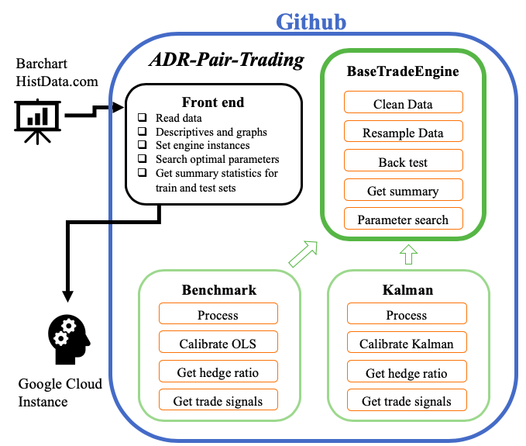To get an impression of the overarching program structure of this project, Figure 2 displays a high-level description of the main classes. The BaseTradeEngine super class is inherited by the two different classes whose purpose is to generate the signals that our back tester will be trading on. The super class provides the functionality to clean the data by merging on overlapping opening hours and altering the input data. The exact nature of these alterations will be given in the next section. Another core functionality is to resample the data. When searching for the optimal parameters of the algorithm, we allow the data to be resampled from one minute to any other frequency by taking the mean of the available data points in the desired interval. This is useful if it turns out that the pattern on a small frequency are too noisy to extract information.

Figure : High level overview of ADR-Pair-Trading repository

The subclasses have a process function which first let it calibrate the hedge ratio at every data point. The hedge ratio represents the amount of ODR that must be traded in opposite direction of the ADR in order to be market neutral. This is an essential task of our algorithm and will be an important factor when determining trading signal. In the Benchmark class, the hedge ratio is determined with a rolling linear regression taking into account a window determined by the parameters. For the Kalman class, the Kalman filter as described in the theoretical framework is applied to forecast the hedge ratio for each future data point. Each subclass then determines when a trading signal is activated. The position management model is kept to simple logic, either raising a single spread buy or spread sell signal such that the position never exceeds one long or one short. The Benchmark class makes a trade when the z-score calculated from a given parameter window exceeds a given entry or exit threshold. The Kalman class creates a signal when the hedge ratio forecast error exceed a given multiple of the standard variance of the predictions. These signals are then passed to the back-testing class of the super class which calculates the portfolio return as a percentage of the invested value at each point in time in a vectorized fashion.

The front end serves to read in the data and setup a method to test out a large variety of parameter inputs to maximize the Sharpe ratio over the first 75% of data. When finding the optimal parameters for a pair, it will evaluate the performance of the algorithm on the test set, namely the final quarter of data available. The train and test splits are essential to avoid strong performance due to some lucky decisions by the signals. The parameter search process also gives us some insight into how sensitive the performance of the model is to changing inputs. Lower variability would point at more stable returns.

## Slippage model and assumptions

When simulating trading behavior, it is essential to account for slippage. This is because on the real market, the price we see is likely not the one we will be getting. In any case, there will always be a spread of a few basis points (bps) wide between the bids and asks placed in a product’s order book at the exchange by passive investors. We assume our strategy to be liquidity taking, and thus actively trade on bids and asks present at the exchange. Although different for every product and usually smaller the more liquid a stock is, we conservatively could estimate the average spread on the LSE and NASDAQ to be 7.5 bps and 5 bps (0.075%, 0.05%) of the price level respectively (Allen & Bercich, 2016). This means that every trade incurs the active trader an instant loss of a few bps. Furthermore, uncertainty tends to dramatically increase the spread to a multiple of itself, meaning that typically trade signals raised through sharp spikes in the underlying price often come with increased slippage too. This can be detrimental to a trading algorithm that fails to take it into account.

In our case, we are given aggregate data on a minute level. A conservative approach would thus be to take the observed minimum traded price as the available bid and the maximum as the available ask level, meaning that we can sell at the lower and buy at the higher price. This is almost a worst-case scenario however, because within the minute there could have been plenty of better bids and asks to trade on that were closer to the mid-price. To further complicate the issue, it is not even clear what the midpoint price really is. Is it the average of the current bid and ask, or rather a volume weighted average of past trades? In our simulation, to settle for a fair standard, we take the last traded price to be the midpoint. The price series generated by this data column will be used to calibrate our models. The Benchmark class uses it to estimates its beta, and thus the hedge ratio, and the Kalman class uses it for its next slope prediction. However, in order to generate the trading signals, we must model the bid and ask price at which we can reasonably expect to trade. This is where the data cleaning method of the Base Trading Engine super class comes in.

First of all, data on the first and last five minutes of the trading day are not considered. These times represent either the opening of the NASDAQ regular trading hours or the closing of the LSE, during which either price discovery or position offsetting trades cause above average volatility and unpredictable slippage. Since our strategy does trade intraday but is not configured as a high frequency algorithm that would take into account these more complicated scenarios with better data, we simply throw these data points out. Next, there are three rules that can be toggled in the algorithm depending on which assumptions the user wants to work with. Any configuration of these rules will be considered a ‘treatment’ of the data. The first rule is to eliminate outliers as defined by mid-point price levels that are further than two standard deviations removed from both the preceding and succeeding observations. Such outliers could be caused by various reasons, such as a sporadic single trade at an odd level that does not represent the true price. The second rule will simply remove any data point where the spread between minimum and maximum price level within the minute exceeds a given threshold. This would be simple way to disregard prices during uncertain times and exclude them from the modelling, similarly to how the first and last five minutes of the trading day are removed. The third rule simply creates a given fixed spread around mid-point which is adjusted up or down to still fall within the maximum and minimum. The rules will always be applied in the described order when they are toggled. Finally, we chose to run the algorithms with seven treatments as given in Table 2. Note that a final failsafe is built into the trading signals that a signal raised on an excessively large spread will not be acted upon regardless of the treatment.

Table : Data cleaning treatments

|  |  |  |  |
| --- | --- | --- | --- |
| Treatment | Remove outliers | Remove wide spread | Adjust spread |
| 0: Base Line | No | No | No |
| 1: No outliers | Yes | No | No |
| 2: Strict spread remove | Yes | > 10 bps | No |
| 3: Soft spread remove | Yes | > 20 bps | No |
| 4: Conservative spread | Yes | > 20 bps | 10 bps |
| 5: Soft spread | Yes | > 20 bps | 7.5 bps |
| 6: Include outliers | No | > 20 bps | 7.5 bps |

In the interpretation of the results, we will pay specific attention to treatments one, two and four because we believe they most accurately reflect the real-life context of the data when taking into account the different possible assumptions discussed earlier.

## Trade signals in the Benchmark and Kalman classes

The two classes of the back-testing algorithm are based on a radically different approach, even though they only differ in terms of how the hedge ratio is calculated when a single buy or sell trade is initiated. While the Benchmark class will be based on a straight-forward and intuitive method that uses historical observations to identify good buying or selling points, the Kalman class will use its state model filtering to actively predict the relationship between the two components of a pair. It will do so by first applying the Kalman filter to each price series itself and then modelling the relationship between the smoothed-out series. This will then be taken as the hedge ratio. The price series will be defined to be the ADR to ODR spread value. Since we are dealing with a bid-ask spread model, we define two price series. The first will be the buying price, which is the calculated price level at which we can purchase a market neutral spread. The market neutrality is based on the estimate of the hedge ratio, meaning the number of one component of the pair is equivalent to the other. The second will be the selling price, at which the spread can be sold. Thus, when we are going long a spread, that means we are buying component $Y$ at the ask price $Y^{A}$ and shorting the hedge ratio $HR$ amount of component $X$ at the bid price $X^{B}$. Shorting the spread constitutes the opposite direction with bid price $Y^{B}$ and ask price $X^{A}$. We can thus define the ask $S^{A}$ and bid $S^{B}$ price of the spread at which we can respectively buy and sell in equation (5) and (6).

$$\begin{aligned}S^{A}=Y^{A}-HR* X^{B}\#\left(5\right)\end{aligned}$$

$$\begin{aligned}S^{B}=Y^{B}-HR* X^{A}\#\left(6\right)\end{aligned}$$

Let us now continue with the logic of the Benchmark class. The hedge ratio will be estimated with a simple rolling Ordinary Least Squares (OLS) regression for a given lookback window. For simplicity, the OLS method will be used to dynamically fit the midpoint of the ODR price series on the midpoint of the ADR price series with a given lookback window. The slope estimation of the OLS regression will be used as the hedge ratio in the calculation of the spread bid and ask price series. The next step will be to determine when a spread price level observation should trigger a trading signal. If returns were normally distributed, one could calculate the z-score of observing a certain price level. If an observation contained a z-score above a given threshold, one would assume in an integrated series that the price would revert back. And thus, selling at high values while buying at the lower points for a given threshold of the z-score would be a simple and intuitive approach to pairs trading. In order to account for the bid-ask model, there will be a separate z-score for a purchase $Z^{P}$ and for the selling $Z^{S}$ signal. The purchase is more likely to good when the current potential buying price is further above the normalized selling price level. More formally, we define our z-score for the selling signal in equations (7) to (11).

$$\begin{aligned}t∈Time, w= lookback window \#\left(7\right)\end{aligned}$$

$$\begin{aligned}S_{t,w}^{A}=\left\{S_{t-1}^{A},S_{t-2}^{A},…, S_{t-w}^{A}\right\} \#\left(8\right)\end{aligned}$$

$$\begin{aligned}{\overline{S}}_{t}^{A}=\frac{\sum{S_{t,w}^{A}}}{w} \#\left(9\right)\end{aligned}$$

$$\begin{aligned}σ\left(S_{t,w}^{A}\right)=\sqrt{\frac{\sum{{{(S}_{t,w}^{A}-{\overline{S}}_{t}^{A})}^{2}}}{w}}\#\left(10\right)\end{aligned}$$

$$\begin{aligned}Z_{t}^{S}=\frac{S_{t}^{B}-{\overline{S}}_{t}^{A}}{σ\left(S_{t,w}^{A}\right)} \#\left(11\right)\end{aligned}$$

Clearly, for the purchasing signal, the same logic holds with the bid price levels of the spread instead of the ask. A purchasing or selling signal will now be triggered the moment the z-score exceeds a user entered threshold. In case of a normal distribution, the z-score would have less than one percent probability of exceeding a value of two. However, given the much fatter tails commonly observed in financial data, it is to be expected that much higher values will be observed and it is up to the parameters search heuristics discussed in the next two sections to set a threshold that is able to identify good opportunities.

The Kalman class provides a more elegant solution by reducing the number of parameters needed to create a signal. Its bounds and threshold can simply be taken as functions of the Kalman filter prediction error and variation. The algorithm will trigger a buying signal when the forecast error drops below a negative multiple of the standard deviation of the prediction, while selling or flattening the position if the error exceeds a positive multiple. The parameter input to be optimized for the multiplier will be split into a $M^{En}$ to determine when to enter a position and $M^{Ex}$ for when to flatten the position. The mathematical notation for how the bid prediction error is calculated is given in equations (12) and (13).

$$\begin{aligned}{\hat{Y}}_{t}^{B}={Intercept}_{Kalman}+{HR}_{Kalman}* X_{t}^{B} \#\left(12\right)\end{aligned}$$

$$\begin{aligned}ε_{t}^{B}=Y_{t}^{B}-{\hat{Y}}_{t}^{B} \#\left(13\right)\end{aligned}$$

With $Q_{t}$ being the variance of Kalman predictions, the Kalman class algorithm would trigger a selling signal if $ε_{t}^{B}>M^{En}*\sqrt{Q_{t} }$ or flatten out the position if it were holding a long and $ε_{t}^{B}<M^{Ex}*\sqrt{Q_{t} }$. For the buying signals, the logic is the same with ask instead of bid prices and the reversed inequality.

## Parameter inputs

At this point, our program is ready to back test the performance on the four ADR to ODR pairs with the Benchmark and Kalman class for each of the seven treatment groups. However, each back-test engine instance can be provided with a number of parameters essential to how signals are generated or to how returns are impacted. In the appendix, Table 15 shows a summary of each of the parameters in addition to an indication which class it is included in. Let us touch upon the different factors coming into the algorithm.

The transaction cost is the variable fee recorded by each electronic exchange based on the traded volume. On the respective websites of the NASDAQ[5] and LSE[6], we find the fees for active trades. NASDAQ charges a fixed 0.003 USD per stock while the LSE considers 0.45 bps of the trade value. To simplify the calculations, we consider that for the average spread, we hedge a value of around 73 USD which translates into 0.0033 USD. Therefore, the transaction cost parameter in our algorithm will be fixed to 0.0063 USD per trade. The lag parameters shift the trade signal by a given number of data points. Initially it was designed to account for the fact that one may not always be able to trade at midpoint at short frequency observations, but this assumption was relaxed with the bid-ask slippage model design. It may still be useful to meet a user’s algorithm design choice but in this research, it will mostly serve as a sanity check that confirms that the trade signals are raised at appropriate times and are not random. Then, the resample parameter, as described in the class structure section, allows to resample the data frequency. It may hold for some price series that patterns become more evident when observed over slower frequencies instead of on a more noise-heavy one-minute level. The rounding parameters rounds of the hedge ratio to a given number of decimals. Theoretically, when reproducing a strategy, it may be difficult to precisely replicate a hedge ratio of more than 2 or 3 decimals because the purchase of ODR is obviously not fractional.

The first two parameters exclusive for the Benchmark class are the z-score calculation window and rolling OLS lookback window. The z-score is calculated with the mean and standard deviation of the data points within the given lookback window and represents the unlikelihood factor of a given observation. It is difficult to know for sure whether for example in volatile times, it is better to take a longer historical mean and variation for the z-score or to only consider the nearer observation to follow a trend. Then, the OLS window serves a similar purpose for the beta estimation. In general, one would expect the slope parameter to be better approximated with a longer historical window because it models more of the long-term patterns in the price series. Next, the entry and exit z-scores are simply the thresholds that the z-score calculation must pass before a position is built up or flattened out. The higher the entry threshold, the lower the chance of transactions occurring. It is thus a trade-off between being sure about good moments to trade and not missing out on the smaller but frequent opportunities. A higher exit threshold will cause the position to be flattened out sooner when it seems that the position no longer has large upside potential. The lower this threshold, the longer the holding period down to the point that it may just always be held until the position is not flattened but simply reversed because it coincides with an entry threshold of opposite direction.

The Kalman filter takes care of the hedge ratio predictions by itself and thus does not require the equivalent of the z-score calculation and rolling OLS window. In theory, one could also automatically set the entry and exit threshold to be the standard deviation of the forecast error prediction, but in practice it may be desirable to adjust these thresholds with a scalar multiple. These multiples are given by the entry and exit multiplier of the Kalman class.

## Parameter optimization

The selection of an optimal set of parameter values is an art of itself. There is extensive academic literate on how the parameter search field can be optimally traversed to obtain the highest model performance. However, it is not the objective of this research to search for a strictly optimal set of parameters. Partly because it would be likely to overfit on price series with changes in regimes as observed in the ADR to ODR pairs we are analyzing and partly because it is the research goal to prove inefficiencies in the continuous ADR premium pricing and not to optimize an algorithm. The approach of parameter search thus settles for a heuristic that none the less will effectively approach a set of best parameter inputs for each ADR pair and data treatment combination.

We call the heuristic we devised a 3D parameter search and it will be executed as follows. For a given set of price series, the algorithm will be provided with a user determined arbitrary default parameter input. It will then vary two of the parameters at a time with a given range of possible parameter values. Each parameter combination will be evaluated based on a performance statistic. This creates a 3D graph of performances for the two ranges of parameter inputs. The algorithm will then change the default values of the two varied parameters with the optimal solution. In Table 3, we describe the pseudo code for this procedure with the training range of a given set of data.

Table : Pseudo code for 3D parameter search

|  |  |
| --- | --- |
| *1* | D 🡨 default parameter inputs |
| *2* | V 🡨 for each parameter input, the range of possible parameter values |
| *3* | O 🡨 an order list of pairs of parameters to iteratively 3D search |
| *4* | C 🡨 back test engine (Benchmark /Kalman) |
| *5* | **For** o in O |
| *6* | V1, V2 🡨 range of parameter inputs for two parameters in o based on V |
| *7* | **For** v1, v2 in V1, V2 |
| *8* | S 🡨 Statistics for engine C with parameter inputs D overwritten by v1 and v2 |
| *9* | D 🡨 D overwritten by v1 and v2 corresponding to optimal S* |
| *10* | D is now best D* |

The valid range of parameter inputs to search for and the order list of parameter pairs to search for is arbitrarily determined by the user based on his understanding of the data properties and algorithm. The default values used in this research can be found in Table 4. Also, for the Benchmark and Kalman classes, a combination of list O and parameter values V can be found in the appendix in Table 16 and Table 17 respectively. The statistic that is optimized for is chosen to be the Sharpe ratio, because it compares the investment return to the involved risk. It will downgrade the performance of undesirable parameter inputs that cause highly varying returns due to, for example, a small number of transactions.

Table : Arbitrary default to start parameter search with

|  |  |  |  |  |  |  |  |  |  |  |
| --- | --- | --- | --- | --- | --- | --- | --- | --- | --- | --- |
| Defaults | *tcst* | *lag* | *rsm* | *rnd* | *zwin* | *owin* | *enZ* | *exZ* | *enM* | *exM* |
| **Benchmark** | 0.0063 | 0 | 5 | 3 | 120 | Yes | 2 | 0 | - | - |
| **Kalman** | 0.0063 | 0 | 20 | 3 | - | - | - | - | 2 | -3 |

After the best set of parameters is determined, its algorithm performance is recorded on both the training and test range. These will be presented in the results section. Evidently, the model evaluation should be strongly based upon the performance on the test range because it may have just gotten lucky with a coincidental overfitting of parameters on the training data.

# Results

## Results introduction

The upcoming section will elaborately describe the finding of our back-testing engines on the given price data. Before taking a look at the performance of our algorithm in the back tests, we will first examine the pair selection metrics as described in the theoretical framework and discuss the implications on our other results. Then, we look at the best parameters found by the 3D search heuristic and what they tell us about the data properties. Also, we dedicate a section to the hedge ratio calculations of the two classes which will give an intuition on how their approaches differ. Then, the results of a range of different performance metrics are presented. Given the large number of findings from our research, we will restrict the discussion of the results to Ryanair, and only one of the other three pairs that did not trade at a premium. In particular, the HSBC pair has been chosen to compare the Ryanair ADR performance to. Furthermore, as mentioned in the methodology, we only discuss the treatments with ID one, two and four. A full presentation of all the best parameters and performance metrics for all the data and all the treatments is given in the appendix.

## Cointegration

|  |  |
| --- | --- |
| **Data** | **P Value** |
| Ryanair | 0.29 |
| Unilever | 1.5e-06 |
| BP | 9.6e-09 |
| HSBC | 5.5e-04 |

In the theoretical framework, cointegration was described as a method to determine the potential of a pair to be traded using mean-reverting price logic. Therefore, let us take a look at the outcomes of the two-step Engle-Granger cointegration test. In Table 5, we show the p-value for the null hypothesis of no cointegration. Clearly, each ADR to ODR pair without consistent ADR premium appear to be strongly cointegrated. Unfortunately, for Ryanair, this is not the case. However, given the trends seen in the descriptive summary, there is not yet reason to believe our algorithms are not suited for the data. To get an idea of the integration coefficient during different period within the Ryanair price series, we performed multiple cointegration tests with a linear trend over a rolling window with 7500 minute-level observations. Its result in Figure 3 show that the series seems to be cointegrated around the beginning and end but not in between. This may be due to a change 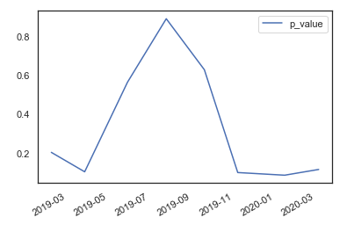in regime within the data that causes any overlapping window to return high p values. If we examine the Ryanair spread price development in the data section, we do observe a downward trend in the first six months, after which the level stayed steadier.

*Table 5: P values for different data sets in Engle-Granger test*

Figure : Rolling p value of Engle-Granger test with window of 7500 observations

Therefore, we ran one more analysis in which we examined the p-values before and after a range of cut-off dates at which we suspect a change of regime to have occurred. Although the period before the cut-off date never reject the null hypothesis of no cointegration in the Engle-Granger test, we do observe cointegration for the period after the first of April 2019. In conclusion, we are still confident that the proposed methods that are based on the assumption of cointegration will be relevant for the Ryanair data.

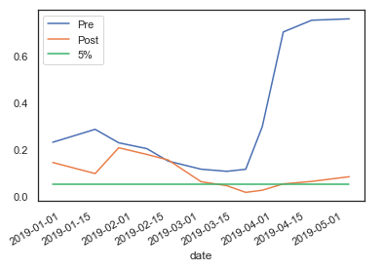

Figure : P values before and after different cut-off dates

## Best parameters

The best parameters were searched by performing 3D searches as described in the methodology and selecting the input values leading to the highest Sharpe ratio. Let us first look at the parameters found by the 3D search for the Benchmark class for Ryanair and HSBC price data in Table 6 and Table 7 respectively. What jumps to eye immediately is that for HSBC, the sampling frequency is reduced more for all treatments as compared to Ryanair. In other words, for the OLS slope estimation to make good decisions, the algorithm prefers to aggregate patterns over longer periods of time as compared to fitting on a more short-term noisier pattern. Also, for HSBC, the entry and exit thresholds are closer together which triggers a trade faster in the case of an anomaly. This is to be expected, since there is much less variance in the spread of the pair without the ADR premium.

Table : Best setting for Ryanair price data with the Benchmark class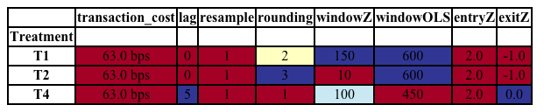

Table : Best setting for HSBC price data with the Benchmark class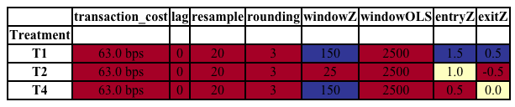

Furthermore, within the different treatments, we observe that for Ryanair, the fourth treatment performed better when it is lagged. In general, we expect that a faster reaction should always be more appropriate. As seen in Figure 5, the Benchmark algorithm already did show a high variability in results based on the window sizes which is an indication that the signals are not consistently producing low risk returns. On the right side, we observe an upward performance trend when increasing the lag, which tells us that the Benchmark signal generation is not working as we would hope with the data under the assumptions of the fourth treatment.

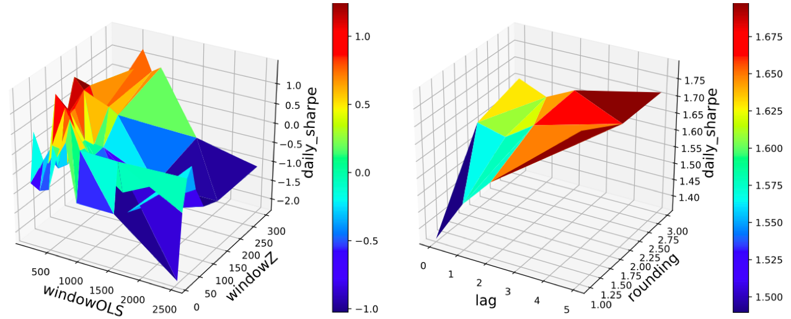

Figure : 3D grids for Ryanair with Benchmark class and T4 for the OLS versus Z-score window and lag versus rounding

Next, in Table 8 and Table 9, the best parameters found for the Kalman class are presented. Similar to the Benchmark class, we observe again that the entry and exit thresholds for the HSBC data are much closer.

Table : Best setting for Ryanair price data with the Kalman class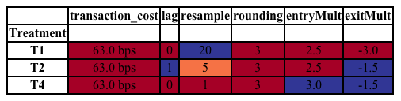

An exception exists for T2 of HSBC, in which we observe a very negative exit threshold. This means that the algorithm prefers to hold a position until it switches the direction of trade completely as opposed to reducing the position when the upside was reduced. The same principle appears to hold for the Ryanair data with the first treatment

Table : Best setting for HSBC price data with the Kalman class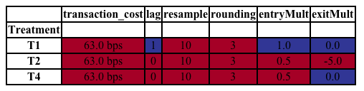

Interestingly, we however now observe that the Kalman class resamples the data to a lower frequency for the Ryanair data for some of the treatments, opposite to the behavior of the Benchmark class. As seen in Figure 6, the effect of resampling on the performance appears quite similar for the different data treatments of the Ryanair price data. However, T4 identified a peak at a high resampling frequency than T1.

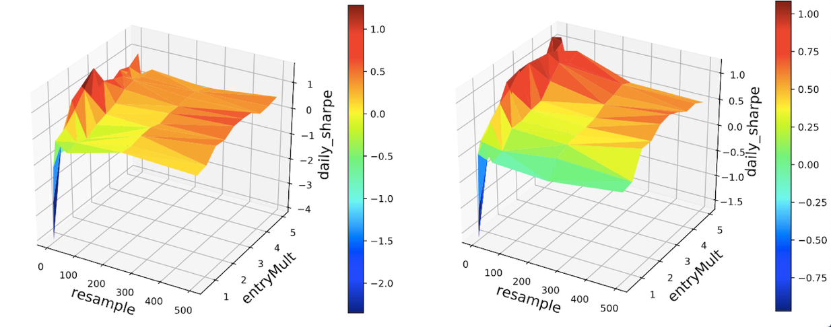

Figure : 3D grid for Ryanair in the Kalman class with T1 (left) and T4(right) for resample versus entry the entry multiplier

## Hedge ratio calculations

In this section, we analyze the difference in hedge ratios that the two classes found for the Ryanair pair. We will not show the relation for the other data since we do not expect their hedge ratio to differ much from being the official conversion rate specified in the data section. In the left and right side of Figure 7, we respectively observe the development of the slope and intercept estimation by the Benchmark class using the rolling OLS regression. Quite surprisingly, this relationship appears to be all over the place, with the slope ranging widely within the dynamic OLS regression window of the Benchmark class. Although there are small temporary differences between the treatments, the parameters under treatment one and two are virtually the same which makes sense given that we in the previous section we saw that they have the same rolling OLS window of 600. The short-term fluctuations and lack of consistent cointegration have given the Benchmark class a hard time at finding consistent hedge ratio estimates and there is reason to suspect these estimates were overfitted on the training sample.

Figure : Intercept and slope estimations for Ryanair data by the Benchmark class for treatments one, two and four

Since the difference in parameter estimates between treatments is small, for the Kalman class we will look at treatment four only. Figure 8 first shows a scatterplot with a range of price levels observations of the Ryanair ADR and ODR color mapped to their respective dates. Its lines are drawn based on the intercept and slope predictions of the Kalman class. From both figures, we can infer that the sloped steadily increased mostly between April and November of 2019 while the slope gradually dropped. This is a much smoother patterns than that seen in the Benchmark class. Finally, note how the dramatic drop in prices in March 2020 are seen in the left bottom data points of the scatter plots. These final observations explain the extreme final change in the slope estimate of the Kalman filter which also comes with a small spike in the slope intercept. This implies that after the stock market crash in March 2020, the ADR premium actually slightly increased, mostly driven by a sharper drop in the ODR than in the ADR.

Figure : Scattered ADR and ODR prices with plotted Kalman filter predictions and slope-intercept estimations

## Algorithm performance metrics

The primary evaluation metric of the algorithm has been the Sharpe ratio. However, in the upcoming section, we also discuss the maximum drawdown (a measure of the worst peak-to-trough decline), the mean holding time in minutes and the number of transactions. Furthermore, in the subsequent table, we also gather a breakdown of the total return into the return on long and short positions, and the loss on the slippage and transaction costs. The metrics are presented for the train and test ranges of the price data, which are the first 75% and last 25% of observation between July of 2018 and April of 2020 respectively for the first, third and fifth treatment. We would expect the number of transactions in the test sample to range from half to one quarter of the transaction in the train sample because the train range is three times longer than the test. The mean holding time will be closely related to the exit threshold and number of transactions. If the barrier to exit is high, and there are few transactions, we can expect the mean holding time to be very high for example. For the Sharpe ratio, the rule of thumb is that a score of one is good, two is very good and three is amazing. The acceptable maximum drawdown is a subjective measure but in the case of arbitrage trading, we ideally would not want to see drops above five percent given the objective of low risk.

## Benchmark class performance

In Table 10, the performance metrics for Ryanair data on the Benchmark class are given. There is quite a high variance in the performances all throughout the table. As expected, for each of the treatments, the algorithm performs worse on the test than on the train sample.

Table : Performance metrics of the Benchmark class on the Ryanair data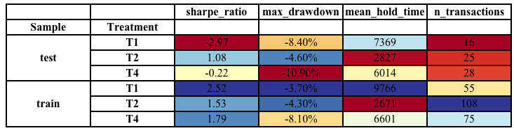

Especially interesting are treatment one and two, which swapped from best to worst performers over the different sample ranges. Looking back at the applied settings, the difference may best be explained by the lower z-score window. As seen in the data and hedge ratio calculation sections, the test range had drastic changes in the price ratio between the ADR and ODR. The small lookback window then likely adapted better to the expected price ratio and did not raise trade signals based on older data points. Comparing with the return breakdown in Table 11, we indeed observe that the returns based on the first treatment seems to have made many wrong buy decisions where it seemed that the spread was cheap because it did not account fast enough for the drop in the ADR premium.

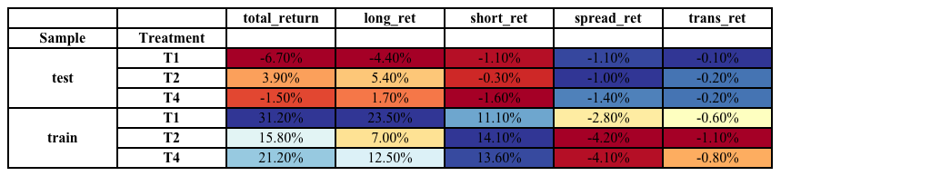Table : Return breakdown of the Benchmark class on the Ryanair data

The performance of the Benchmark class on the HSBC data set is very similar to the one discussed for Ryanair. Practically all of the potential benefit found on the train sample disappears when applying the algorithm to the out of sample range, implying that the parameters were overfitting the initial data and made a return more based on luck than actual consistent patterns. This is supported by the 3D grid in Figure 9 which shows that the first stage of the parameter searches only found positive returns for a small range of possible parameter inputs. Also, observe that the maximum drawdown is much smaller for the HSBC data, because the ADR to ODR pair without consistent premium does not have large price swings and thus reduces variability in returns. This also holds for Unilever and BP as we can see in Table 24 in the appendix, where the return is much lower than for the Ryanair data but also with much less variation. This benefits the Sharpe performance which rewards low risk. However, as hypothesized, the larger return appears to stem mostly from the ADR premium component.

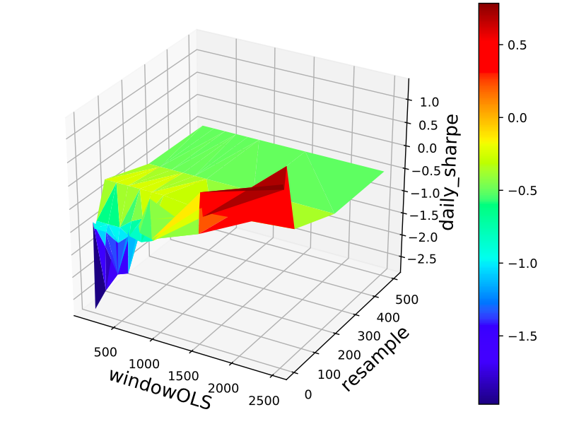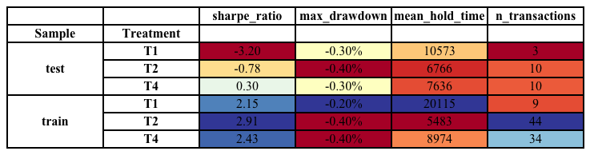Table : Performance metrics of the Benchmark class on the HSBC data

Figure : First stage of the 3D search method for Ryanair in the Benchmark class with T2 for resample versus OLS window

## Kalman class performance

Next up, we will examine whether the hedge ratio calculation of the Kalman class can make up for the shortcomings of the Benchmark. Again, we first look at the performance on the Ryanair data in Table 13. Immediately, we observe a much consistent performance between the train and test sample ranges. Technically, observing slightly and more consistent Sharpe ratios on the training range promises a smaller overfit as compared to what we observed in the Benchmark. Also, the maximum drawdown is more consistent and much lower. Finally, the number of transactions is much higher, although the test sample has relatively few trades.

Table : Performance metrics of the Kalman class on the Ryanair data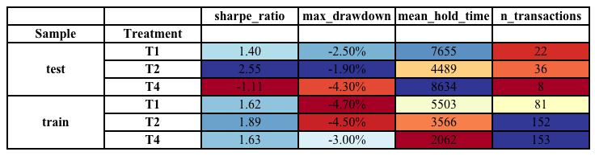

However, the results are not perfect. As we can also see in Table 25 in the appendix, some of the treatments did lead to a drastically worse and even negative performance as compared to treatment one and two. Before we dismiss the performance of the Kalman class to be as variable and unreliable as the Benchmark class, let us first examine the obvious difference in the settings found for these different treatments. It jumps to eye that the treatments which triggered a larger resampling window to be used performed much better. Given the changes in the financial markets, it may be true that the algorithm underperforms when extrapolating parameters throughout different context. The simple implementation of the back-testing engine in the research does not allow to account for this but could be improved to do so in a larger set up. For now, let’s examine what happens in the back-testing engine when the resampling frequency is reduced for treatment four. In Figure 9, the cumulative return for different resampling rates is given, showing that the higher rates make more trading decisions and especially in the final month are resistant to the sharp drops in the ADR premium component. The resampling rate of 50 works best and with a return of six percent even reached a Sharpe ratio of 2.07 which can be considered very good.

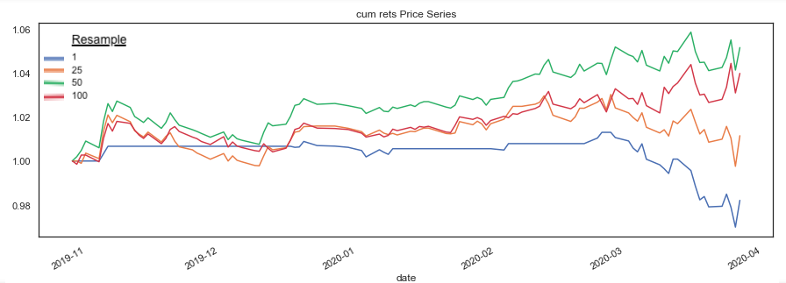

Figure : Cumulative return in the test sample of Ryanair with T4 using the Kalman class and varying the resampling rate

Just to get an understanding of why the down sampled frequency of 50 works so much better from the initial setting of 1, let us dive into the actual trading signals of the final month where the low resampling rate especially failed our algorithm. Figure 11 shows the bid and ask of the spread using the calculated hedge ratio marked including the trading signals by the Kalman filter on the final month of Ryanair data using treatment four for a resampling rate of 1 and 50. We clearly see that outliers caused by temporary swings in the one of the underlying components caused the algorithm with high resampling frequency to trade out of positions to early, especially with the short entered around the 13th of March and the long purchased on the 18th. The lower resampling rate did not only calculate a spread price at a slightly different price level but also smoothened out the swings in the price which led to more reasonable decisions.

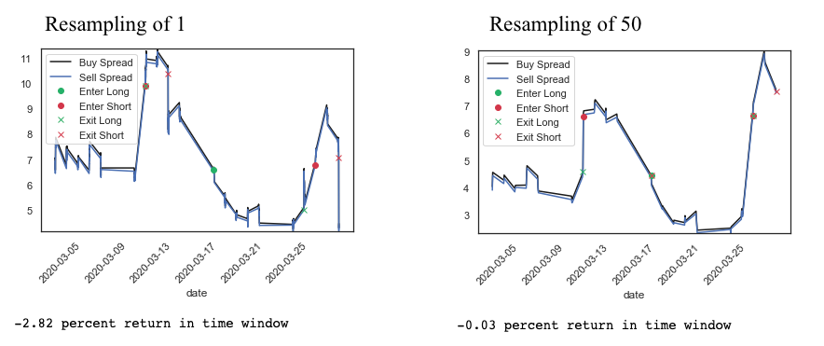

Figure : Trading signals generated for Ryanair data with T4 using the Kalman class with different resampling rates

Finally, we also examine the performance of the Kalman class on the HSBC data. As for the Benchmark class, we observe how the positive returns found in the train sample do not reappear in the test range. For the first treatment, it did not even identify a single trading signal to act upon. When looking at Table 25 but also Table 21 in the appendix, we can confirm that for the ADR to ODR pairs without premium, there does not appear to be any power to generate positive returns outside of the training sample with either the Kalman and the Benchmark algorithms. The few examples where the Sharpe ratio does end up positive are in cases where the number of transactions is so small that they are likely just a lucky strike.

Table : Performance metrics of the Kalman class on the HSBC data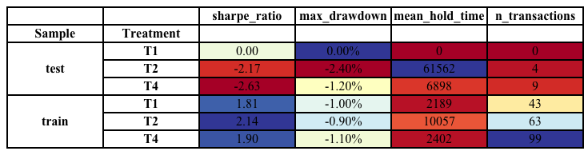

In fact, the one surprising factor is that the algorithm was even able to generate a positive return in the training sample since there should be little unexploited opportunities in these pairs. In Figure 12, we observe the cumulative returns for the different data sets using treatment one over the training sample. It can be clearly seen that for HSBC and BP, there is something going on at the end of 2018 after which not much happens anymore. For HSBC, the underlying reason is possibly related to the higher ADR premium we observed in the first months of data as seen in the descriptive summary, but more in-depth analysis would be necessary for a definite explanation. For Unilever, the returns take off after the second half of 2019 but then stop. Only the Ryanair data shows consistent returns at a steady rate over the whole sample. Further research would be needed to explore how these opportunities arose in the first place, but this is out of scope for this paper. The most important take away is that we found significant opportunities only for the ADR to ODR pairs with a consistent price premium.



Figure : Cumulative returns on the different pairs with T1 using the Kalman class

# Conclusion

## Limitations

The first limitation of any trading simulation study is of course that one cannot know what impact the trades would have had on the market were they actually executed. Generally, to limit the hypothetical impact of such trading, simulations are restricted to a certain percentage of total trades in a brief time period. Fortunately, with an average daily volume of just under 3 million shares on the LSE and about 600’000 ADR on the NASDAQ (equivalent to 3 million local shares), there is a lot of room for large volume pairs trading in Ryanair. Furthermore, it is difficult to confirm the patterns found in this research given the exceptional case of the Ryanair ADR premium. Finally, when working with high frequency data, many assumptions have to be made about the slippage model and on the prices at which may be traded. The fact that we work with aggregated data did not make this easier.

## Final words

Although the results of this research cannot be taken as conclusive evidence of the effectiveness of the described methods, it certainly does show that there are opportunities in the Ryanair ADR case that have not been exploited. Furthermore, the expectation that there should not be profitable trade opportunities in ADR to ODR pairs without a consistent price premium was met. The research question can thus be answered positively. This may be explained by the lack of interest of arbitrageurs to optimally maintain the price relationship because of the complexity of the underlying supply and demand mechanisms and the lack of scalability. We finally encourage the reader to extend the methods described in this research to pairs trading strategies in other closely related products or other applications in finance where price relationships are modelled.

Bibliography

Grossman, S. J., & Stiglitz, J. E. (1980). On the Impossibility of Informationally Efficient Markets. *The American Economic Review, 70*(3), 393-408.

Alsayed , H., & McGroarty, F. (2011). Arbitrage and the Law of One Price in theMarket for American Depository Receipts. School of Management, University of Southampton. UK.

Rosenthal, L. (1983). An empirical test of the efficiency of the ADR market. *Journal of Banking & Finance, 7*(1), 17-29.

Chowdhry, B., & Nanda, V. (1996). Stabilization, Syndication, and Pricing of IPOs. *Journal of Financial and Quantitative Analysis, 31*(1), 25-42.

Liu, L. (2014). *International Cross-Listing of Chinese Firms.* IGI Global.

Kurapka, D. (2000). The Truth About Price Differences Between ADRs and Their Home Shares. From https://www.thestreet.com/markets/the-truth-about-price-differences-between-adrs-and-their-home-shares-1094904

Chan, J. S., & Subrahmany, M. G. (2008). Liquidity and Asset Prices in Multiple Markets. NYU Working Paper No. FIN-05-006.

Wigglesworth, R., & Rennison, J. (2018). Bond Trading: technology finally disrupts a $50tn market. *Financial Times*.

Goetzmann, W., Gatev, E. G., & Rouwenhorst, G. (1998). Pairs Trading: Performance of a Relative Value Arbitrage Rule. *Yale School of Management Working Papers*.

Krauss, C. (2017). Statistical arbitrage pairs trading strategies: Review and outlook. *Journal of Economic Surveys*(2), 513-545.

Engle, R. F., & Granger, C. (1987). Co-Integration and Error Correction: Representation, Estimation, and Testing. *Econometrica, 55*(2), 251-276.

Herlemont, D. (2003). Pairs trading, convergence trading, cointegration. *YATS Finances and Technology* .

Fuller, W. A., & Dickey, D. A. (1976). Distribution of the Estimators for Autoregressive Time Series with a Unit Root. *Journal of the American Statistical Association , 74*(366a), 427-431.

Dunis, C., Giorgioni, G., Laws, J., & RUdy, J. (2010). *Statistical Arbitrage and High-Frequency Data with an Application to Eurostoxx 50 Equities.* Centre for International Banking, Economics and Finance, Liverpool.

Huck, N., & Afawubo, K. (2015). Pairs trading and selection methods: is cointegration superior? *Applied Economics, 47*(6), 599-613.

Elliott, R. J., Van der Hoek, J., & Malcolm, W. P. (2005). Pairs Trading. *Quantitative Finance, 5*(3), 271–276.

J.P. Morgan. (2014, 2). From jpmorgan.com: https://www.jpmorgan.com/cm/BlobServer/ADR_Arbitrage_and_Program_Balances.pdf?blobkey=id&blobwhere=1320635141557&blobheader=application/pdf&blobheadername1=Cache-Control&blobheadervalue1=private&blobcol=urldata&blobtable=MungoBlobs

Ryanair. (2015, 4). *LIMITATIONS ON SHARE OWNERSHIP BY NON-EU NATIONALS.* From https://investor.ryanair.com/wp-content/uploads/2015/04/2014-AR-Limitations-on-Share-Ownership.pdf

Ryanair. (2020). *Hard Brexit & Non-EU shareholders.* From https://investor.ryanair.com/brexit/

Church, E. (2002, 2 5). *Ryanair: Too U.S. for us.* From marketwatch.

MSCI. (2019). *Consultation on specific topics related to investment limits.*

Spero, J., & Stafford, P. (2019, 3 11). *Ryanair and KT face stock turmoil over removal from indices.* From Financial Times.

Allen, M., & Bercich, J. (2016, 11 2). *Insight.* From https://www.fca.org.uk/insight/uk-equity-trading-costs-continue-decline

Kalman, R. E. (1960). A New Approach to Linear Filtering and Prediction Problems. *Journal of Basic Engineering*, 35-45.

Cowpertwait, P., & Metcalfe, A. (2009). *Introductory Time Series with R.* Springer.

Pole, A., West, M., & Harrison, J. (1994). *Applied Bayesian Forecasting and Time Series Analysis.* Chapman & Hall.

Quantstart. (2019). *State Space Models and the Kalman Filter.* From Quantstart: https://www.quantstart.com/articles/State-Space-Models-and-the-Kalman-Filter/

Welch, G., & Bishop, G. (1995). *An Introduction to the Kalman Filter.* University of North Carolina at Chapel Hill.

Bayes, T., & Price, R. (1763). An Essay towards solving a Problem in the Doctrine of Chance. *Philosophical Transactions of the Royal Society of London, 53*, 370–418.

# Appendix

## Kalman filter equations

Overview of relationships:

|  |  |
| --- | --- |
| $$a_{t}=G_{t}m_{t-1}$$ $$R_{t}=G_{t}C_{t-1}G_{t}^{T}+W_{t}$$ $$e_{t}=y_{t}-f_{t}$$ $$m_{t}=a_{t}+A_{t}e_{t}$$ | $$f_{t}=F_{t}^{T}a_{t}$$ $$Q_{t}=F_{t}^{T}R_{t}F_{t}+V_{t}$$ $$A_{t}=R_{t}F_{t}Q_{t}^{-1}$$ $$C_{t}=R_{t}-A_{t}Q_{t}A_{t}^{T}$$ |

Each of the components of the Bayes’ rule equation (4) is modelled as a multivariate normal distribution. Distribution of prior belief of current state has mean of previous mean multiplied with the current transition matrix and variance developing as the previous state covariance matrix multiplied by the squared transition matrix plus the covariance matrix of the system noise.

$$\begin{aligned}{θ_{t}|D}_{t-1} ∼N\left(a_{t}, R_{t}\right)\#\left(14\right)\end{aligned}$$

The likelihood function of the current observation has mean of the current state multiplied by the matrix of equation (3) and variance equal to the measurement error covariance matrix.

$$\begin{aligned}y_{t}|θ_{t} ∼N\left(F_{t}^{T}θ_{t}, V_{t}\right)\#\left(15\right)\end{aligned}$$

Finally, the distribution of the posterior belief of the current state has mean and variance equal to those of the prior belief plus a factor incorporating the new information of the current observation which can be derived from the relationships seen above.

$$\begin{aligned}{θ_{t}|D}_{t} ∼N\left(m_{t}, C_{t}\right)\#\left(16\right)\end{aligned}$$

In order to make forecasts, we derive the expected value and variance of the one step ahead observation given the historical data up to the current period in equations (17) and (18).

$$\begin{aligned}E\left[y_{t+1} | D_{t}\right]=E\left[F_{t+1}^{T}θ_{t}+v_{t+1} | D_{t}\right]=F_{t+1}^{T}a_{t+t}=f_{t+1}\#\left(17\right)\end{aligned}$$

$$\begin{aligned}Var\left[y_{t+1} | D_{t}\right]=Var\left[F_{t+1}^{T}θ_{t}+v_{t+1} | D_{t}\right]=F_{t+1}^{T}R_{t+1}F_{t+1}+V_{t+1}=Q_{t+1} \#\left(18\right)\end{aligned}$$

Thus, we now have an exact formulation of the one step ahead forecast mean and variance. In equation (19), we generalize these formulas to a $k$ step ahead forecast distribution.

$$\begin{aligned}y_{t+k}|D_{t} ∼N\left(f_{t+k|t}, Q_{t+k|t}\right) \#\left(19\right)\end{aligned}$$

The $\left(t+k | t\right)$ subscript is a short hand for the full formulas respective to the current time index t. The exact calculations are shown in equations (20) to (22).

$$\begin{aligned}{f_{t+k|t}=F}_{t+k}^{T}G^{k-1}a_{t+1} \#\left(20\right)\end{aligned}$$

$$\begin{aligned}{Q_{t+k|t}=F}_{t+k}^{T}R_{t+k}F_{t+k}+V_{t+k} \#\left(21\right)\end{aligned}$$

$$\begin{aligned}R_{t+k|t}=G^{k-1}R_{t+1}{\left(G^{k-1}\right)}^{T}+\sum_{j=2}^{k}{{G^{k-j}W}_{t+j}{\left(G^{k-j}\right)}^{T}} \#\left(22\right)\end{aligned}$$

## Data and Methodology tables

Table 15: Parameter Overview

|  |  |  |  |
| --- | --- | --- | --- |
| Parameter | *Benchmark* | *Kalman* | Description |
| Transaction cost (tcst) | Yes | Yes | Transaction cost in USD of the total trade value of taking a long or short position in the spread. |
| Lag  (lag) | Yes | Yes | Lags the trade signal, so in effect causes a slower reaction. A good algorithm would function best with zero lag. |
| Resample  (rsm) | Yes | Yes | Resample the frequency of the minute data by taking the mean of the data points within the given interval. |
| Rounding  (rnd) | Yes | Yes | Round the hedge ratio to a given number of decimals to better imitate real life imitation. |
| Z-score window (zwin) | Yes | No | Z-score is calculated with the mean and standard deviation of the data points within the given lookback window. |
| OLS window (owin) | Yes | No | The rolling OLS beta estimation is fitted on the data points within the given lookback window. |
| Entry Z-score (enZ) | Yes | No | A trade will be executed when the absolute Z-score exceeds the given threshold. |
| Exit Z-score (exZ) | Yes | No | The position will be flattened when the absolute Z-score falls below the given threshold. |
| Entry Multiplier (enM) | No | Yes | Multiply the standard deviation of the forecast error to set the entry threshold. |
| Exit Multiplier (exM) | No | Yes | Multiply the standard deviation of the forecast error to set the exit threshold. |

Table : Iterative optimal parameter search for the Benchmark class. (x - y:z denotes a range from x to y with step size z)

|  |  |  |  |
| --- | --- | --- | --- |
| Benchmark 3D Search | *Parameter* | *Values* | *Reasoning* |
| **First** | owin | 150 - 1200:150 | Set the most representative resampling period first and optimize for the OLS window parameter which will determine how good the slope is. |
| rsm | 1,5,10,20,60,300 |
| **Second** | owin | 150 - 1200:150 | For the given resampling period, further optimize the OLS- and Z score calculation window by searching a large range of possibilities (48 combinations). |
| zwin | 25 – 150:25 |
| **Third** | exZ | 0.5 – 3:0.5 | Search the best combination between an entry and exit threshold. The higher the entry, the less transactions, and the lower the exit, the longer the holding times. |
| enZ | -5 - 0.5:0.5 |
| **Fourth** | enZ | -5 - 0.5:0.5 | Double check whether the resampled frequency works best for the calculated entry and exit thresholds. |
| rsm | 1,5,10,20,60,300 |
| **Fifth** | lag | 0 - 5 | Sanity check the lag and rounding. In general, lag should always perform best at zero because it corresponds to the fastest response time and rounding should permit for more precision. |
| rnd | 1 - 3 |

Table : Iterative optimal parameter search for the Kalman class

|  |  |  |  |
| --- | --- | --- | --- |
| Kalman 3D Search | *Parameter* | *Values* | *Reasoning* |
| **First** | enM | 1 - 5:0.5 | Set the most representative resampling period first and optimize for the entry multiplier which has a big impact on when trades are executed. |
| rsm | 1,5,10,20,60,300 |
| **Second** | enM | 1 - 5:0.5 | Search the best combination between an entry and exit threshold. The higher the entry, the less transactions, and the lower the exit, the longer the holding times. |
| exM | -5 – 0:0.5 |
| **Third** | lag | 0 - 5 | Sanity check the lag and rounding. In general, lag should always perform best at zero because it corresponds to the fastest response time and rounding should permit for more precision. |
| rnd | 1 - 3 |

Table : Data points left after merging on data and treatments are applied

|  |  |  |  |  |
| --- | --- | --- | --- | --- |
|  | Ryanair | UL | BP | HSBC |
| *ADR Data* | 110795 | 157682 | 159878 | 158089 |
| *ODR Data* | 134001 | 134550 | 170453 | 168684 |
| *Merged* | 27152 | 31631 | 36055 | 35856 |
| *T0* | 27152 | 31631 | 36055 | 35856 |
| *T1* | 26454 | 31108 | 35473 | 35251 |
| *T2* | 12616 | 26958 | 25448 | 30599 |
| *T3* | 21089 | 29706 | 32382 | 33904 |
| *T4* | 21089 | 29706 | 32382 | 33904 |
| *T5* | 21089 | 29706 | 32382 | 33904 |
| *T6* | 21547 | 30196 | 32885 | 34465 |

## All Results

Table : Best settings found by 3D search for Benchmark class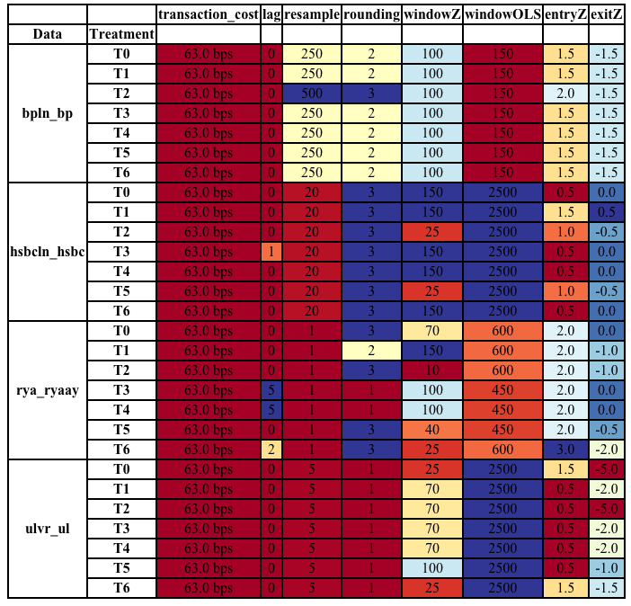

Table : Best settings found by 3D search for Kalman class 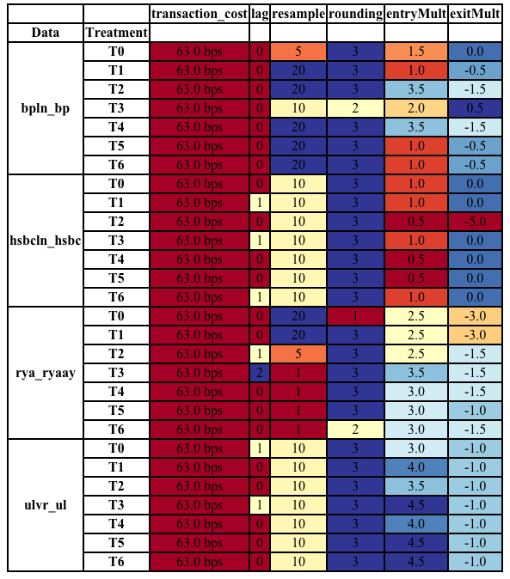

Table : Performance results of the Benchmark class on the test samples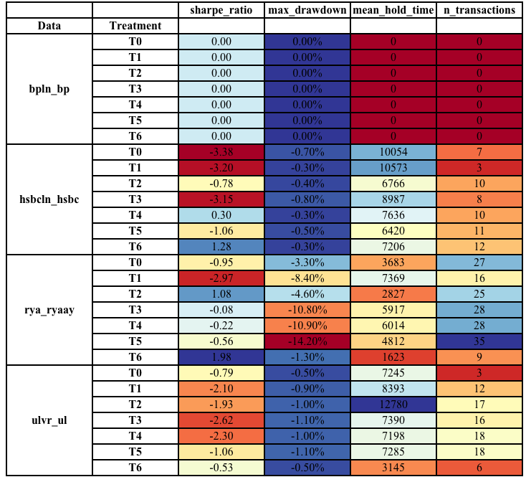

Table : Return breakdown of the Benchmark class on the test samples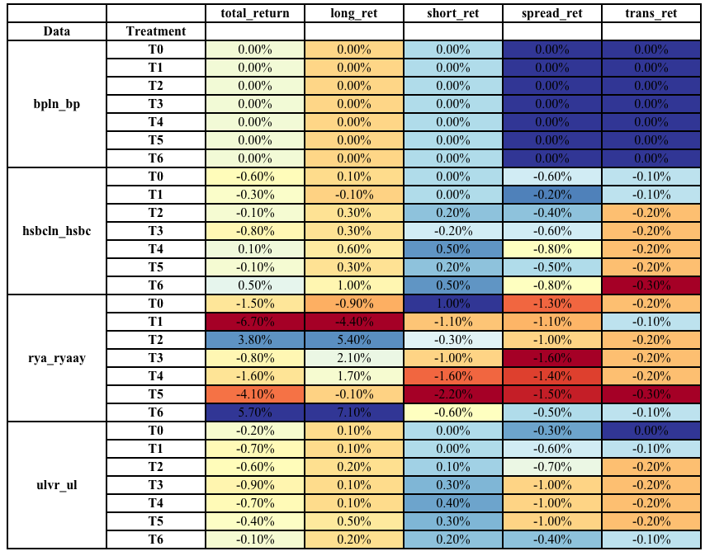

Table : Performance results of the Benchmark class on the train samples 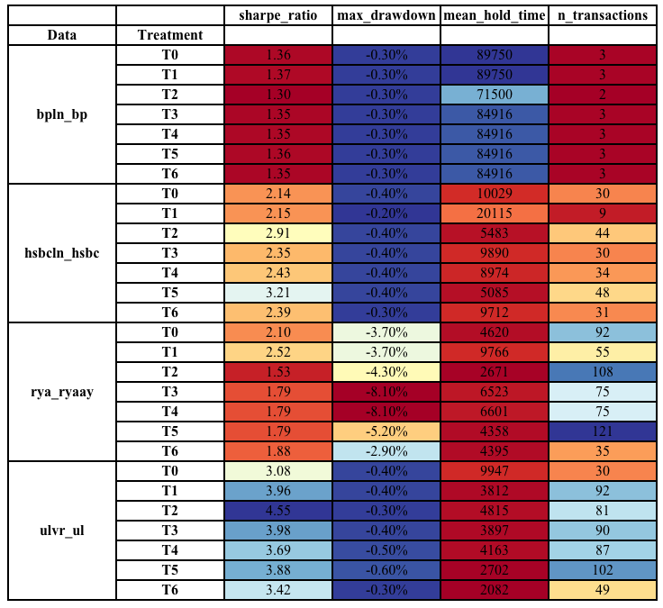

Table : Return breakdown of the Benchmark class on the train samples 

Table : Performance results of the Kalman class on the test samples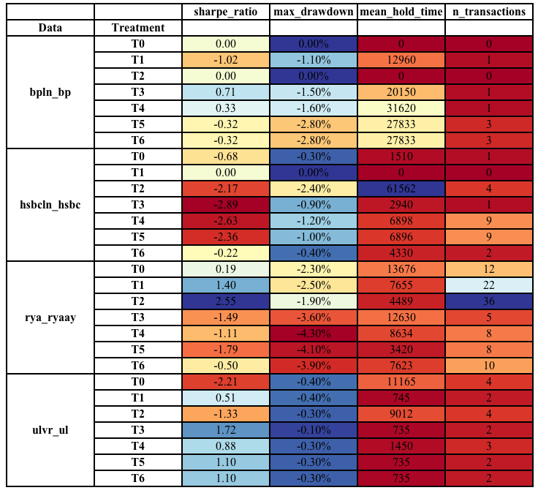

Table : Return breakdown of the Kalman class on the test samples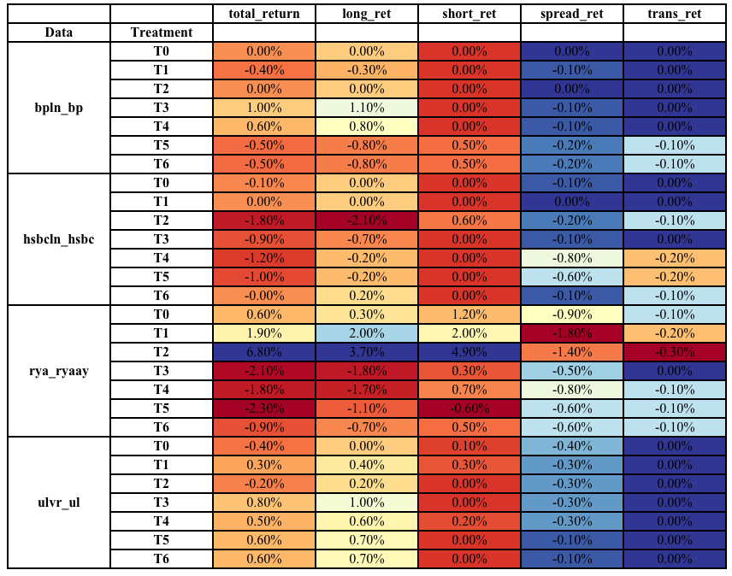

Table : Performance results of the Kalman class on the train samples 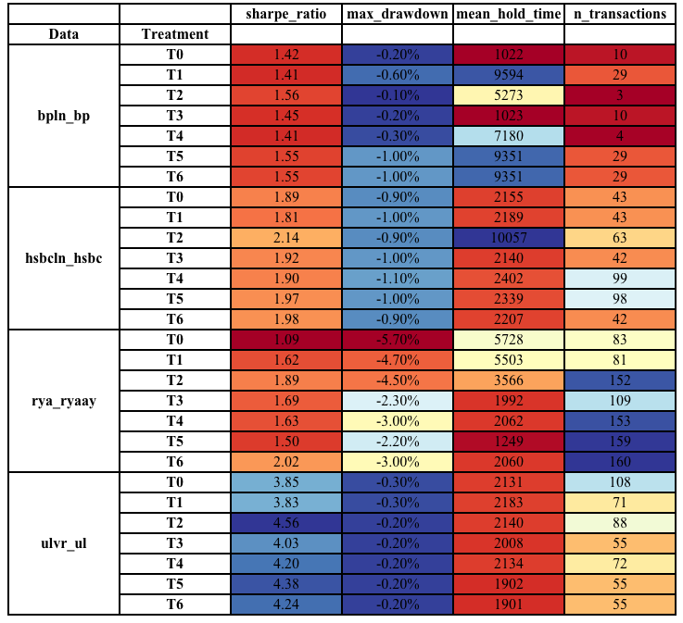

Table : Return breakdown of the Kalman class on the train samples 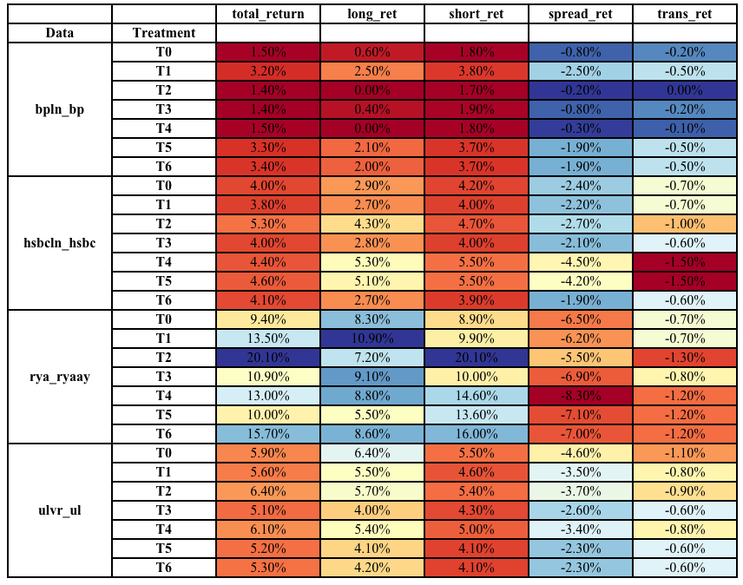

1. Investor information on conversion rates:

   <https://www.ryanair.com/doc/investor/2012/EGM_2012_WEB.pdf>
2. <https://www.unilever.com/investor-relations/shareholder-centre/about-shares/nv-and-plc-stock-exchange-listings/commentary-on-tax-treatment-of-dividend-capital-gains.html>
3. <https://www.bp.com/content/dam/bp/business-sites/en/global/corporate/pdfs/investors/bp-shareholder-administration-faqs-ads-holders.pdf>
4. <https://depositaryreceipts.citi.com/adr/guides/pgm_d.aspx?pageId=15&subpageid=106&cusip=404280406&typeDisplay=T>
5. <http://nasdaqtrader.com/Trader.aspx?id=PriceListTrading2>
6. <https://www.lseg.com/sites/default/files/content/Trading%20Services%20Price%20List_2020_0.pdf>